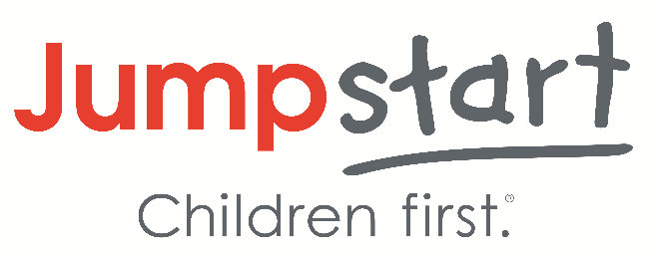

Jumpstart Extra Hours Event

**Material Preparation Event**

Mondays 12-2pm

12-2pm

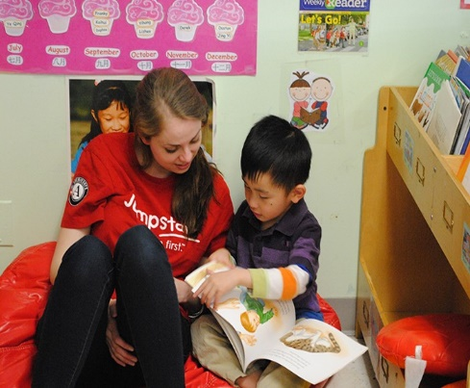

**Material Preparation DETAILS**

Volunteers will help prepare Jumpstart session plan materials for the children we serve in Kansas City preschools. Volunteers will support efforts such as cutting out, printing, organizing, designing, and laminating materials/activities used in the weekly Jumpstart sessions.

**About Jumpstart**

Jumpstart is a national early education organization working toward the day every child in America enters kindergarten prepared to succeed. We provide language, literacy, and social-emotional programming for preschool children from under-resourced communities and promote quality early learning for all children. Since 1993, we have trained more than 50,000 college students and community volunteers to transform the lives of over 123,000 preschool children nationwide.

**Directions to Jumpstart Office**

**Jumpstart Office Address**

* 4825 Troost Ave, Suite 215, Kansas City, MO 64110
* The office suite is located on the 2nd floor on the Northeast side of the building.
* Student parking (with parking pass) and metered parking is available.

**UMKC Campus Map & Shuttle Schedule**

* Shuttle Map: <https://www.umkc.edu/maps/>
* Shuttle Schedule: <https://www.umkc.edu/transportation/shuttle-bus/index.html> or <https://www.umkcbus.com/routes>

**Values CELEBRATED DURING EVENT**

**Joy:** Incorporate fun and excitement into our daily work. Celebrate success in genuine ways and treat each other with respect. **Community:** Build connections across diverse backgrounds and nurture strong, inclusive relationships to champion quality education for children. Cultivate shared goals and trust through thoughtful internal and external partnership to achieve greater impact than any individual effort.

**Event COORDINATOR CONTACT inFORMATION**

If you have any questions regarding this event, please contact:

**Community Engagement Coordinator:** Bryley Smith

**Phone:** 316-494-2733

**Email:** blsyw6@umsystem.edu

**\*\*\*Please contact the Community Engagement Coordinator with questions or concerns regarding the event\*\*\***